Accessing Brands Information

In order to access the new Brands section of the Credentials program, open the agency web site at https://agriculture.az.gov and go to the ADA Employee area. In that section is a menu item that indicates “Brands Information’. This will take you to the new Credentials program, and you should see a screen like this:
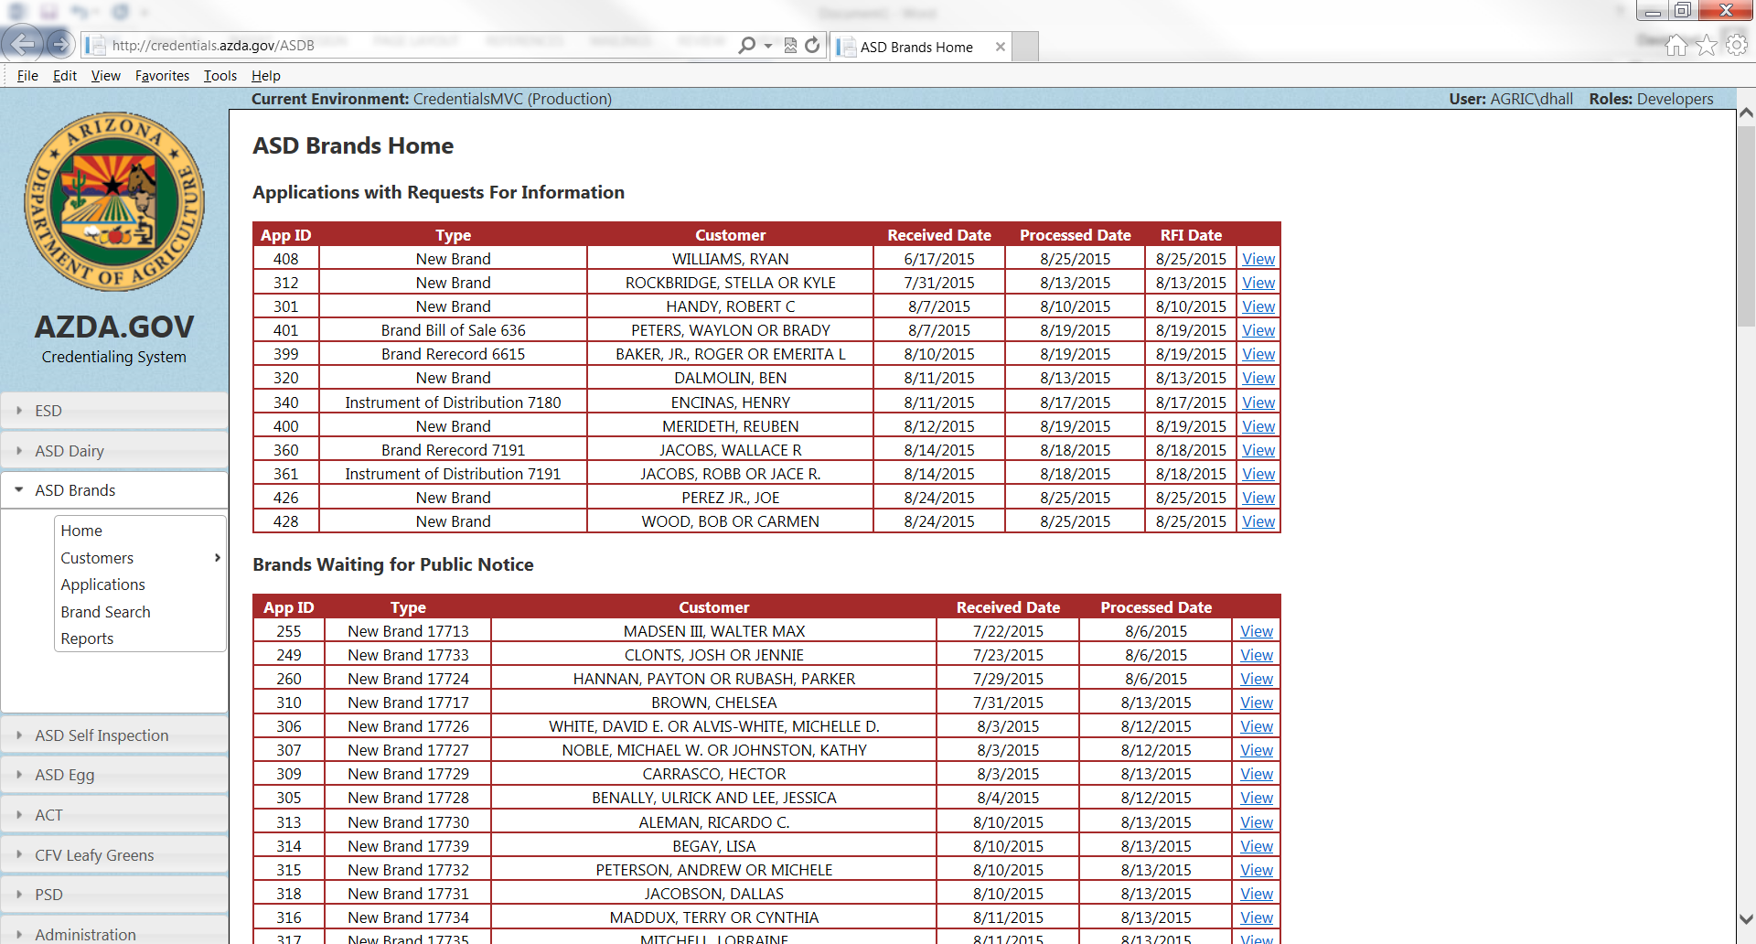
Depending upon what you wish to do, click on the topic, such as ‘Customers’ to search or find a brands customer by name, address, etc such as this:
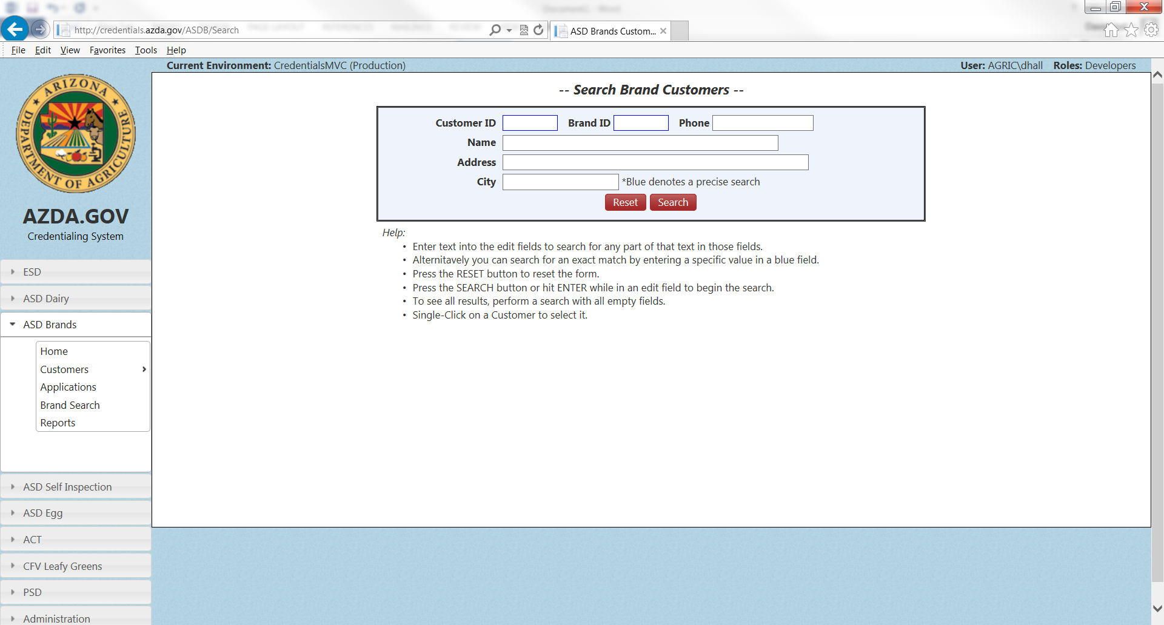
The more interesting part is the Brands search itself. If you click on ‘Brand Search’ it brings up this screen:
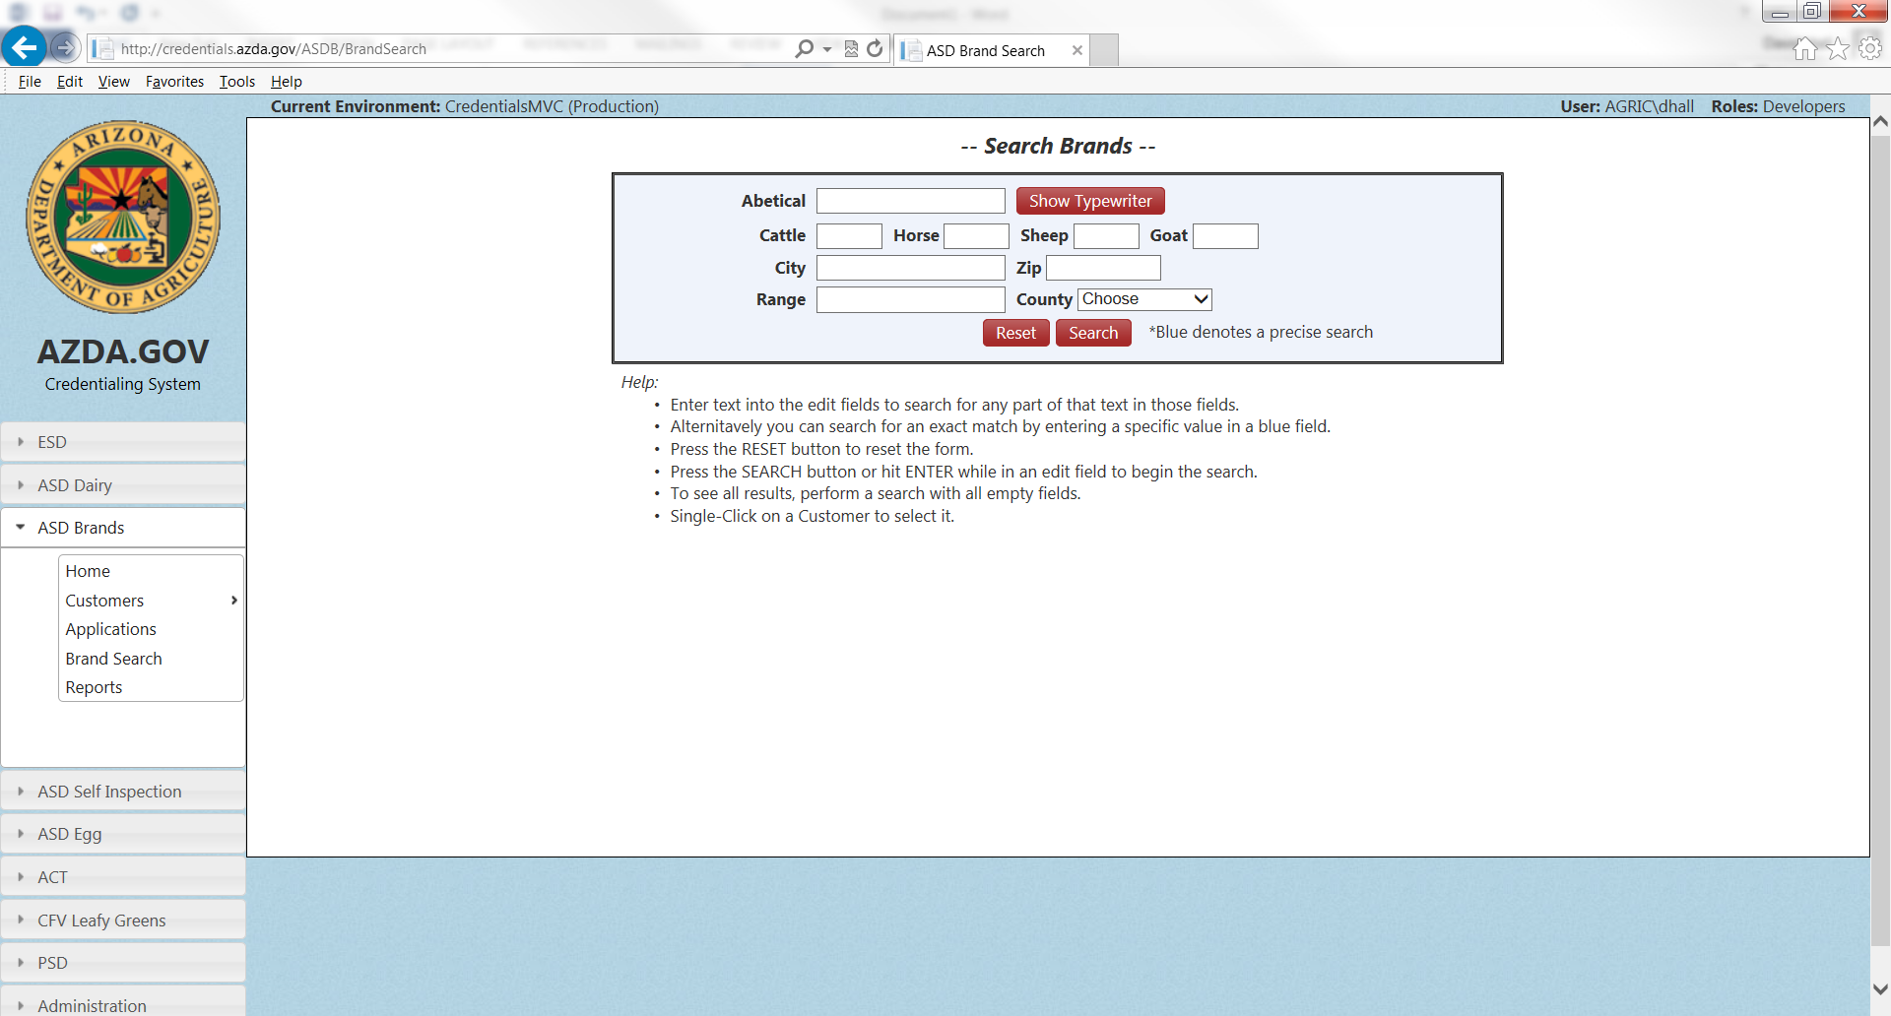
The perhaps confusing part is the area for ‘Abetical’. This is how the brands designs are recorded in computer terms, so it will be helpful to hit the button called ‘Show Typewriter’. This is where those symbols (rocker, slash, rafter, etc) will be placed into the Abetical area for searching the brand symbol. The areas for Cattle, Horse, sheep, and goat all refer to the location of the brand, i.e. LH for left hip, RS for right shoulder, etc. You may also search by city or zip, or any combination of these fields that you wish. It should be noted that you do NOT have to fill in all the areas to perform a search. To get more broad results, only search one or two fields, such as the Abetical and cattle ‘RH’. Many times the Abetical alone will find the brand owner.
In the ‘Reports’ area, there are a number of reports you may run, including an up to the minute Brands Book with phone numbers. Please remember, that the phone numbers of our clients should not be distributed.

We hope this new tool will enable you to perform your duties better. If there are any questions, do not hesitate to let me know at dhall@azda.gov.

